Accelerated Motion Lab
/14
Name: _______________________
Problem: Determine the acceleration of the dynamics cart.
Materials:
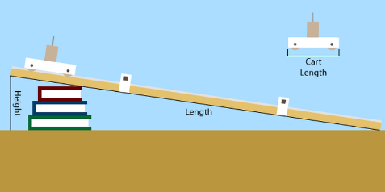
- Dynamics Cart
- Ticker Timer
- Ramp
Procedure:
- Set up the ramp at an angle of approximately 15º angle.
- Place the puck at the top of the ramp.
- Set the timer to 1/10 s and press the pedal.
- Plug in the vacuum pump and release the puck.
- Measure the distances between the dots on the tape and record in the table.
Observations: (2)
Dot | Time (s) | Displacement (cm)
1 | 0
2 | 0.10
3 | 0.20
4 | 0.30
5 | 0.40
6 | 0.50
7 | 0.60
8 | 0.70
9 | 0.80
10 | 0.90

- Sketch a graph of position vs time and identify the shape of the graph. (2)

X: [ , , ]
Y: [ , , ]

Analysis:
- What function of t would have to be graphed to produce a linear position time graph? (1)

- Using your initial table of values, create a second table of values that will allow you to create a linear graph. (2)
Dot |  | Displacement (cm)
1
2
3
4
5
6
7
8
9
10

- Sketch a graph of the data from the table. (2)

X: [ , , ]
Y: [ , , ]

- Determine the slope of the line of best fit. Be sure to include the units of the slope. (1)

- Using your line of best fit determine the acceleration of the car. Be sure to include the units! (3)

