Uniform Motion in 2 Dimensions

- A swimmer can swim at a speed of 1.6 m/s. If she swims due north into a river that flows with a current of 0.8 m/s East,
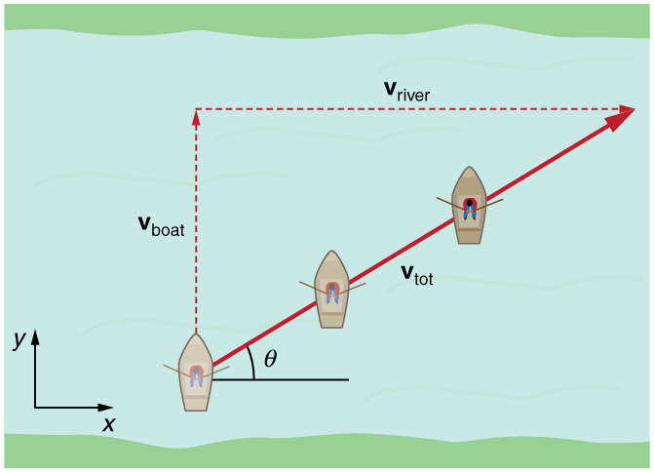
How wide is the river if it takes her 30 seconds to cross? (48 m)

- How far downstream will she end up? (24 m [East])

- If her intention is to finish crossing directly north of her starting point, in what direction should she swim? (30° W of N)

- How long will it take to swim across if she plans to swim in this direction? (35 seconds)

2. A man throws a Frisbee for his dog to fetch. The Frisbee flies at a constant 8.0 m/s [East]. The Frisbee is carried by a wind of 4.5 m/s [25˚ W of S], how far and in what direction would his dog need to run to catch the Frisbee 8.0 s after it’s thrown? (59 m [34° S of E])

3. A ship sailing 40˚ [N of W] is 80 km further north after 4.0 hours. What is the velocity of the ship? (31 km/h [40° N of W])

4. You are crossing a swift but shallow river. You can wade across by walking on the muddy riverbed at a speed of 0.90 m/s or you can swim through the water at 1.4 m/s. If you swim however, you must swim in a direction upstream to compensate for the 1.0 m/s current. Which is the faster method of crossing the river? (swimming, by 0.08 m/s)

5. While skating at 5.5 m/s along the blue line in hockey you shoot a puck at the goal when it is directly to your right. Assuming the puck continues travelling forward at 5.5 m/s without friction and your shot is 35 m/s, at what angle relative to the blue line should you shoot the puck so that it hits the goal? (81°)

6. You must swim across a cold, 15 m wide river to a dock directly opposite your position on the far shore. To minimize time in the water you decide to walk upstream and then swim at an angle of 90° to the shore. If you estimate that you can swim at 1.25 m/s in cold water and the river is flowing at 3.0 m/s then how far upstream should you start your swim to arrive at the dock precisely? (36 m)

At what angle relative to the shoreline do you approach the dock? (23°)

