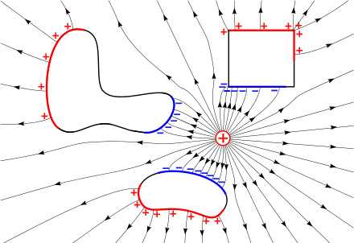

Physics 30
Unit B
Electricity & Magnetism

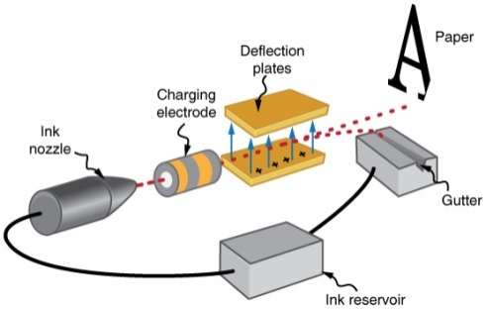
Examples and Practice Questions
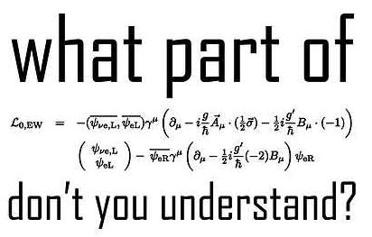

Lesson 1 – Introduction to Electrostatics
- A Van de Graff generator causes a charge of 5.5 mC to build up on its metal sphere. How many excess electrons are required for this charge?

- Consider 4 charges A, B, C & D
    - A attracts B
    - A is repelled by D
    - C is repelled by B
    - C is positive
Identify the charge on each of the objects

- Two charged metal spheres of equal mass have charges +5 C and – 3 C. The spheres are brought into contact and then separated. What will the charge on each sphere be?

Lesson 2 – Coulomb’s Law
- What is the electrical force between two electrons (q = - 1.6 x 10⁻¹⁹ C) separated by 2.0 m?

- Two oil drops have equal but opposite charges of 1.5 μC. If they experience of force of 0.1 N how far apart are they?

- Two charged objects produce an electric force of 3.5 x 10⁻⁴ N. What is the electric force between them if the charge on each objects triple and distance between them double?

- Two lead shot-puts each with a mass of 2.5 kg are given a charge of 2.5 C and separated by 1.0 m.
  - Determine the electric and gravitational force acting on these shot-puts.

  - How many times larger is the electric force then the gravitational force?

- Three charges are placed in a line as shown below. Determine the net electrostatic force on the center charge.
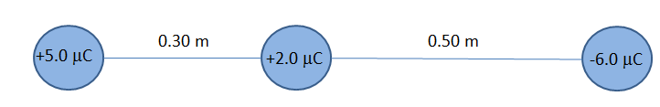

Lesson 3 – Electrostatics in 2 Dimensions
- A metal sphere with a charge of 3.5 μC is brought into contact with an identical, neutral sphere. The spheres are then separated to a distance of 0.15 m. What is the magnitude of the electrostatic force between them?

- Find the magnitude of the electric force acting on q₂
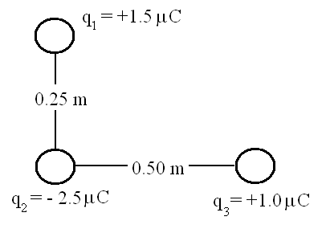

- Where can a positive charge be placed so that it experiences no net electric force?
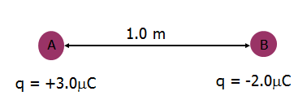

- Determine the electric force acting on charge B below:

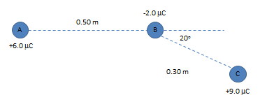

- Two pop cans (m = 15.0 g) are suspended by a 0.50 m string. One of the cans is given a charge q and then the two cans are touched together. The cans repel as shown in the diagram. Determine the magnitude of the charge on one of the cans.
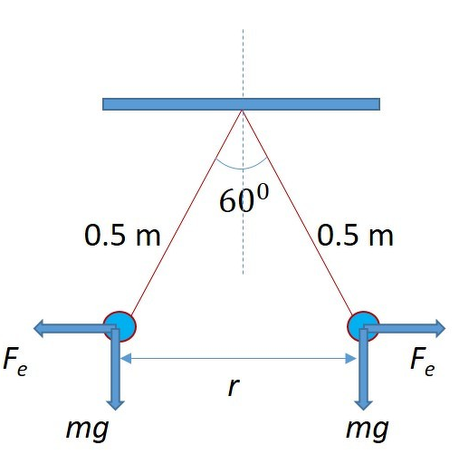

Lesson 4: Graphical Analysis
- Measuring the electrostatic force between two pith balls (q₁ = 3.0 μC & q₂ = 2.5 μC) as separation was changed produced this data:
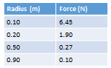
Create a graph of this data. Follow the steps outlined and create a linear graph of the data. What is the relationship between F and r?

Lesson 5: Electric Fields
- An electron experiences a force of 2.0 N when placed inside an electric field. What is the magnitude of the electric field?

- A bolt of lightning results from a cloud having an electric charge of 3.5 C. How far from the cloud would you have to stand for the electric field strength to be 1000 N/C?

- A proton is accelerated by an electric field of 2500 N/C.
  - What is the magnitude of the electric force the proton experiences? What is the magnitude of its acceleration?

  - If it started from rest, how long would it take to reach a velocity of 2.5 x 10⁶ m/s?

- An electron experiences an acceleration of 2.5 x 10¹⁰ m/s² due to an electric field. What is the electric field strength?

- A 0.10 g glass bead is charged by the addition of 1.5 x 10¹⁰ excess electrons. What electric field E will cause the bead to hang in the air?

- A graphite sphere (m = 5.00 g) is given a charge of5.0 μC and is placed inside a uniform electric field. The ball is suspended as shown in the diagram.
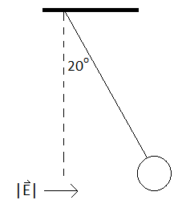
- Is the sphere positively or negatively charged?

- Determine the magnitude of the electric field.

Lesson 6: Electric Field as Vectors
- Two charged objects each produce electric fields at point P. Object A’s field at P is 1.5 N/C East and object B’s field at P is 3.3 N/C at West. What is the net electric field at point P?

- Determine the electric field at point P below:
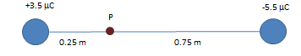

- Determine the electric field at point P:
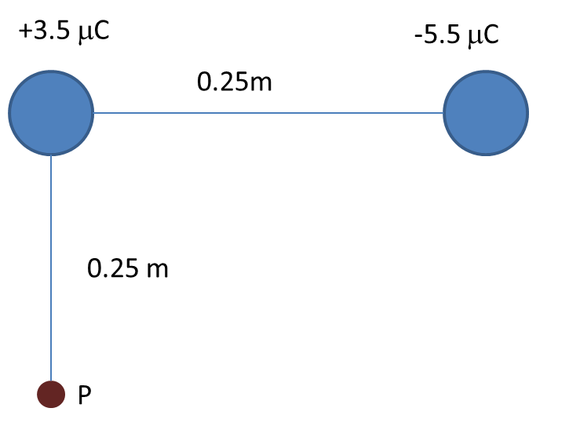

- Draw the electric field lines around the charges below:
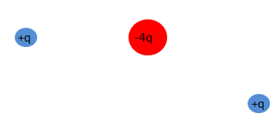
Lesson 7: Uniform Electric Fields
- Charges accelerate through parallel plates; these are often called accelerating potentials
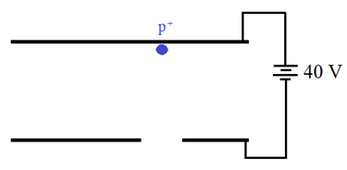
- How much kinetic energy will the proton gain?

- What velocity will it have a when it leaves the parallel plates?

- In order to accelerate an electron what would you have to change?

- Will a proton or an electron reach a higher speed?

- The electrons in a computer monitor gain 3.8 x 10⁻¹⁷ J of energy as the travel through the monitor. What is the electric potential of the Cathode Ray Tube? What will the electron’s change in velocity be?

- An electron is accelerated from 1.0 x 106 m/s through 250 V.
  - Determine the final kinetic energy of the electron in electron volts and Joules.

  - Determine the final speed of the electron.

- A computer draws 3.2 A from its battery.
  - What charge is needed to power the computer for 30 minutes?

  - How many electrons must flow through the computer?

Lesson 8 – Charged Particles in Uniform Fields
- The newly completed CERN can accelerate protons to 500 MeV.
  - How many Joule’s of energy does each protons have?

  - What is the (non-relativistic) velocity of these protons?

- An electron starts at the negative plate of parallel plate capacitor as shown below. Use the diagram to complete the chart below.
Distance from positive plate (cm) | Kinetic Energy (eV) | Potential Energy (eV) | Total Energy (eV)
10.0
8.00
6.00
4.00
2.00
0
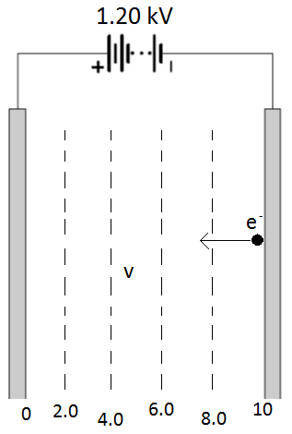

- How much kinetic energy (in eV) does an electron gain moving from point A to I? From point A to point II? From I to II?

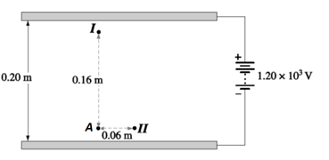

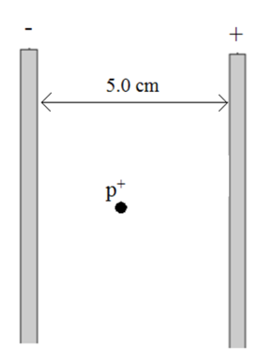
- A proton starts from rest half way between a set of parallel plates as shown. The electric field is 1.50 x 10⁵ N/C between the plates.
  - Indicate the direction of the electric field.
  - Determine the proton’s speed as it reaches the negative plate.

- An electron and a proton both travel through a 250 V potential difference. If they each start with a velocity of 1.00 x 10⁶ m/s determine the final velocity of each particle.

- An alpha particle is accelerated from a point with an electric potential of 500 V to a point with 0 V.
  - What is the change in kinetic energy of the alpha particle?

  - If the alpha particle starts from rest what is its final velocity?

- A proton has a speed of 3.5 x 10⁶ m/s. How much kinetic energy does it have? What voltage is required to bring it to a stop?

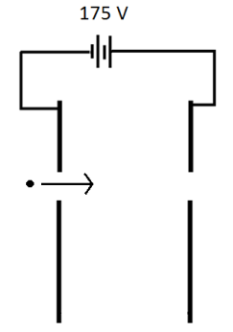
- A proton travelling at 2.0 x 10⁵ m/s enters the parallel plates below.
  - Determine the speed that it leaves them at.
  - Determine the speed an electron travelling at 2.0 x 10⁵ m/s would leave the plates at.

- An electron is moving towards two parallel plates as shown below with a speed of 2.07 x 106 m/s. A potential difference of 350 V is connected to the plates. The electron travels a vertical distance of 5.00 cm while in between the plates. What horizontal distance does it travel?
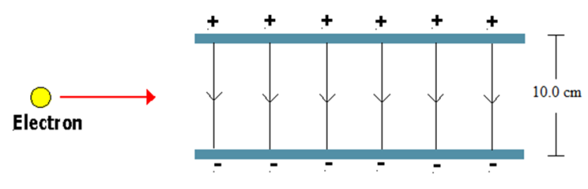
Lesson 9: Oil Drop Experiments
- An oil drop has a mass of 1.54 x 10⁻¹⁶ kg. It is held stationary by an electric field of 1350 N/C.
  - What is the charge on the oil drop?

  - How many excess electrons does the oil drop have?

- An oil drop with a mass of 5.61 x 10⁻¹⁵ kg and 130 excess electrons is held stationary in an electric field. The field is created by parallel plates separated by 10 cm. What is the potential difference between the plates?

- An oil drop with a charge of 3.5 x 10⁻¹⁰ C and a mass of 8.5 x 10⁻⁹ kg is placed in an electric field. The oil drop accelerates upwards at +0.75 m/s². What is the magnitude and direction of the electric field?

- When conducting an oil drop experiment with a mass of 1.2 x 10⁻¹⁵ kg the voltage is adjusted so the oil drop accelerates at various rates. The plate separation is 5.0 cm The data below is gathered:
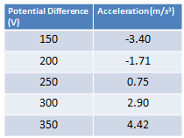
- Identify the manipulated and responding variables.

- Graph the data.

- Write a linear equation (y = mx + b) that represents the data.

- What does the slope represent? What does the y-intercept represent?

- Use the slope of the graph to determine the charge on the oil drop.
Lesson 10: Introduction to Magnetism
- Draw the magnetic field lines (with arrows to indicate direction) of the magnetic field around:

Lesson 11: Direction of Magnetic Fields
      - An electromagnet is used to pick up paper clips and has poles as shown below:
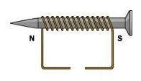
What is the orientation of the battery powering the electromagnet?

- A typical wire carries about 5 A of current. What is the magnetic field strength 10 cm from this wire?

- Calculate the current in a long straight conductor if it produces a magnetic field of 2.6 x 10⁻⁵ T at a distance of 25 cm.

Lesson 12 – Lorentz Force
      - Determine the magnitude of the magnetic force an electron particle experiences if it travels at 2.5 x 10⁶ m/s through a 0.50 T magnetic field.

      - A proton experiences a force of 2.50 x 10⁻¹⁸ N when travelling perpendicularly through a magnetic field of 1.75 x 10⁻² T. Determine the velocity of the proton.

      - A charged particle travels at 5.00 x 10⁵ m/s at a right angle through a 0.45 T magnetic field. If it experiences a force of 0.63 N determine the charge on the particle.

      - Calculate the downward acceleration on an electron traveling east through a 2.5 x 10⁻¹ T [W] magnetic field at a speed of 9.0 x 10⁴ m/s.

      - An electron is accelerated from rest by a potential difference of 1.70 x 10³ V and then enters a magnetic field of 2.5 x 10⁻¹ T moving perpendicular to the field. What is the magnitude of the force acting on the particle?

Lesson 13 – Cathode Ray Tubes, Mass Spectrometers and Velocity Selectors
      - A charged particle moves in a circular path due to a magnetic field. Will an increase in the magnetic field result in a larger or smaller circle? Will an increase in the velocity result in a larger or smaller circle? Prove this.

      - Derive an express for the radius of a particle traveling through a mass spectrometer.

      - Derive an express for the charge to mass ratio of an ion moving through a mass spectrometer.

      - A beam of doubly ionized atoms are accelerated through a 66.0 V potential difference in a mass spectrometer that has a magnetic field of 0.050 T. The particles make a circular path of radius 0.106 m. Find the mass of each atom.

      - A sample of Carbon is taken from Mike the Mighty Explorer. Mike wants to know if it is Carbon-12 or Carbon-14 so he puts it into a mass spectrometer. The isotope is given a single positive charge and is accelerated through a 2660 V potential difference before it travels through a 1.5 x 10⁻¹ T magnetic field. It hits the detector after making a circle with a radius of 13.2 cm. What type of Carbon is it?

      - What velocity would an electron have to have in order to pass through perpendicular electric and magnetic fields with strengths of 12000 N/C and 1.2 x 10⁻² T?

      - A scientist accelerates electrons in a CRT using a 2000 V accelerating potential. He then adjusts the electric and magnetic fields so the electrons are not deflected. The follow data is gathered. Determine the charge to mass ratio of the electron.
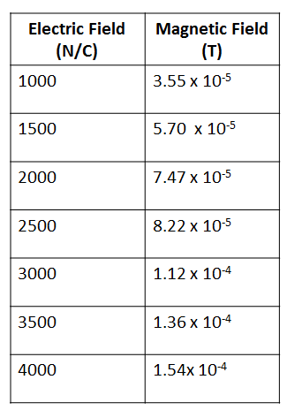

Lesson 14: Current Carrying Wires
- If a compass needle is placed above a current carrying wire which way will the needle point if conventional current flows through the wire ‘into’ the page?

- A copper wire carries a current of 12.5 A perpendicular through a 0.065 T magnetic field. If the wire experiences a 0.350 N force what is the length of the wire?

- A wire carrying 2.5 A of current is placed in a magnetic field. If the wire is 2.5 m long and has a mass of 200 g what must the magnetic field strength be in order to balance the force of gravity?

- A wire carrying 2.5 A of current is placed in a magnetic field. If the wire is 2.5 m long and has a mass of 200 g what must the magnetic field strength be in order to balance the force of gravity?

Lesson 15: Faraday & Lenz’s Law
- The wing span of the space shuttle is 23.5 m. Knowing the Earth’s magnetic field is 5.0 x 10⁻⁵ T find the maximum voltage that can be produced on the surface of the shuttle if its maximum velocity is 7.6 km/s.

- Determine the polarity of the electromagnets:

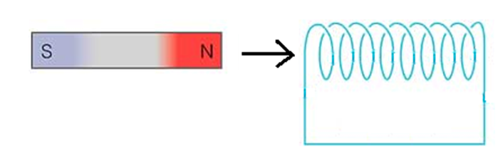

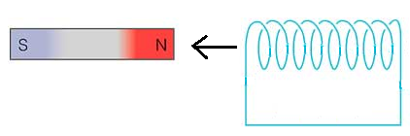

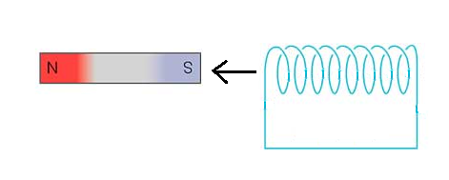
- A circular loop of wire is placed near a large, current carrying wire. What direction must the loop move in order to induce a current in it?

- An induced current is flowing counterclockwise through a loop of wire. The current is caused by a permanent magnet moving through the coil. What pole of the permanent magnet must be moving towards the coil?

- A magnet is pushed through a coil of wire and the resulting polarity of the coil is shown. Determine the polarity and direction of movement possible to induce this current.
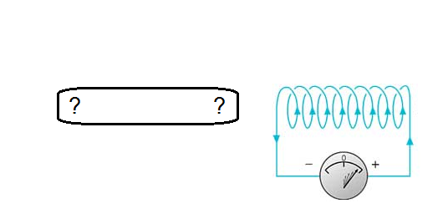

- The conducting rod in the diagram below is 0.50 m long and is moved at a constant speed perpendicular to a 0.65 T magnetic field. If the induced voltage is 0.50 V what speed is the rod being pushed at?
