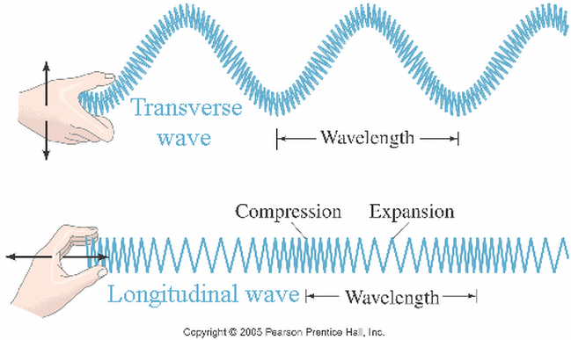

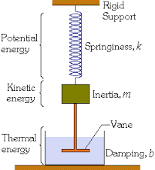

Waves & Simple Harmonic Motion
Students Examples Package
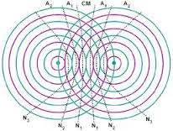
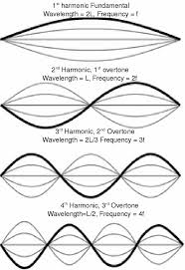

Lesson 1: Hooke’s Law & Elastic Potential Energy
- A spring (k = 15 N/m) has a natural length of 30 cm. How much force does it take to stretch it to 40 cm?

- A spring (k = 17 N/m) is stretched 20 cm from its equilibrium position. Determine the acceleration a 750 g object would experience.

- When designing a rollercoaster engineers plan on stopping the 350 kg car with a spring shock absorber. If that car will be traveling at 10 m/s and must be brought to a stop it 3.5 s what should the spring constant of the shock absorber be?

- A 100 g mass is on the end of a spring that is compressed 0.15 m. As it passes through equilibrium the mass is moving at 2.5 m/s. Determine the spring constant.

- A catapult is designed by using a bungee cord. The cord (k = 2500 N/m) is stretched 1.5 m and a 3.0 kg Physics Textbook is fired.
  - Determine the maximum height the textbook could reach.

  - What is the maximum range of the textbook?

Lesson 2: Period of Simple Harmonic Motion
- A 250 g object is vibrating in SHM at the end of a spring. If the object takes 1.5 s to go through one full motion, determine what force is required to compress the spring 0.25 m.

- If a pendulum with a length of 2.0 m swings on earth what is the period? What if it was taken to the moon? (g = 1.60 m/s²)

- How long must a pendulum be to have a period of 1.00 s?

- Determine the acceleration due to gravity if a pendulum 0.50 m long has a frequency of 0.90 Hz.

Lesson 3: Graphing Simple Harmonic Motion
- A pendulum was set at various lengths and its period was measured. The data is summarized in the table :
Length (cm) | Period (s)
10 | 0.63
20 | 0.90
35 | 1.20
65 | 1.63
80 | 1.82
100 | 1.97
150 | 2.40
- What condition must be satisfied for a pendulum to swing in SHM?

- Identify the manipulated and responding variables

- Graph the data.
x: { , , }
y: { , , }

- Create another column of data for T²
- Create a graph of T² vs l
x: { , , }
y: { , , }

- Write an equation in the form y = mx + b

- What does m represent? What does b represent?

- Determine the value of m and use it to calculate the value of g.

- A spring vibrates in SHM when various masses are placed on it. The period of the springs vibration is recorded in the table below:
Mass (g) | Period (s)
65 | 0.78
80 | 1.84
120 | 2.15
200 | 2.32
300 | 3.46
500 | 4.50
650 | 5.05

- Identify the manipulated and responding variables

- Graph the data.
x: { , , }
y: { , , }

- Create another column of data for T²

- Create a graph of T² vs m
x: { , , }
y: { , , }

- Write an equation in the form y = mx + b

- What does m represent? What does b represent?

- Determine the value of m and use it to calculate the value of k.

Lesson 4: Kinematics of Simple Harmonic Motion
- A 75 g mass vibrates in SHM at the end of a spring (k = 15 N/m). If the maximum displacement of the mass is 0.12 m, what is the maximum velocity?

- A 80.0 g mass is swung on the end of a 50.0 cm string. The mass is pulled so that it makes an 8.00º angle with the vertical and then released. Determine its speed at equilibrium.

- A ball is vibrating on the end of a spring (k = 4.0 N/m) along a frictionless surface. If the maximum speed is 0.50 m/s and its maximum displacement is 0.29 m what is its speed when its displacement is 0.10 m?

- A spring (k = 25 N/m) experience SHM and vibrates with a frequency of 1.4 Hz reaching a maximum displacement of 10 cm. Determine the maximum acceleration of the spring.

- A 250 g object is swung on the end of a pendulum with a length of 0.75 m. The object reaches a maximum speed of 1.0 m/s at equilibrium.
  - Determine the maximum height the pendulum will reach

  - Determine the angle with respect to the vertical made by the pendulum

  - Determine the maximum acceleration of the pendulum.

Lesson 5: Wave Basics
- What angle from the normal does light reflect off mirror B in the diagram?
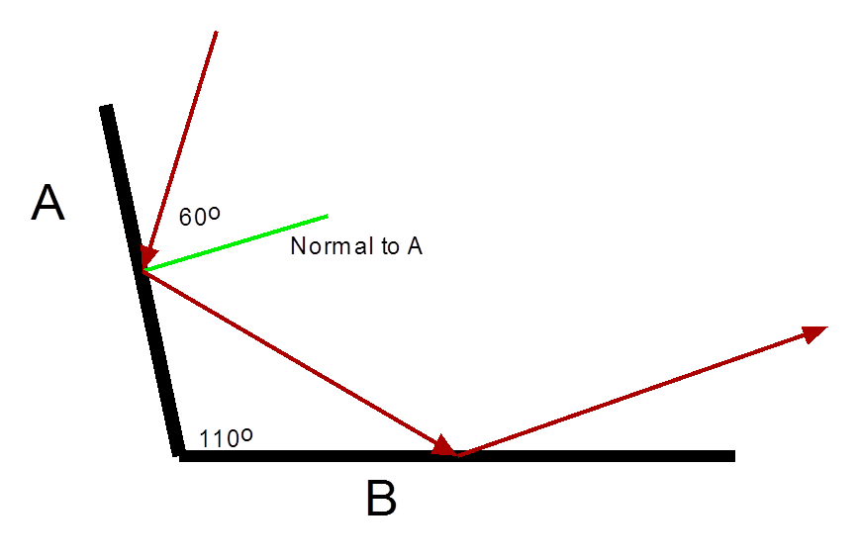

- The radio wave from a cell phone has a frequency of 850 MHz and travels at a speed of 3.0 x 10⁸ m/s. What is the wavelength of this radio wave?

- A sound wave travels at 335 m/s. If its wavelength is 10.0 cm, determine the frequency of the wave.

- A baby creates waves in a bath tub by sloshing around 6 times every second. If the wavelength is 25 cm how fast is the wave moving?

Lesson 6: Diffraction & Interference
- Where does bad light end up?

- What animal is made up of calcium, nickel and neon?

- What do physicists call a benzene ring with iron atoms replacing the carbon atoms?

Lesson 7: Snell’s Law
- What is the speed of light in diamond?
v₁ = 3.00 x 10⁸ m/s n₁ = 1.00
n₂ = 2.42

- What is the angle of refraction and speed of light in water if the incident angle in air is 40.0⁰?
v₁ = 3.00 x 10⁸ m/s n₁ = 1.00
n₂ = 1.33

- A wave in a lake travels at 15.0 cm/s in deep water. It approaches a sand bar at a 30.0º angle with respect to the normal and travels through the sandbar at a 19º with respect to the normal. Determine the waves speed across the sandbar.

Lesson 8: Mechanical Resonance
- A pipe organ can be approximated as a closed pipe resonator. If the speed of sound in air is 343 m/s find the minimum required length for a pipe to play middle C (f = 256 Hz)

- When you blow across the opening of a bottle it will resonant at a specific frequency. A typical coke bottle is 25 cm tall. At what frequency should it resonant at?

- How long should a flute be for its fundamental frequency to be middle C (256 Hz) if the speed of sound in air is 343 m/s?

- An opened pipe organ is 3.6 m long.
  - Determine the wavelength of the fundamental frequency of this pipe.

  - If the speed of sound is 343 m/s what is the frequency of this note?

  - What would the frequency of the third harmonic on this column be?

Lesson 9: Doppler Effect
- A police car is traveling at 60 km/h. The car’s siren has a frequency of 1500 Hz.
  - What frequency will you hear from the siren when the car travels towards you and away from you? (Speed of sound is 343 m/s)

  - Determine the wavelength of the sound waves in both cases.

- When stationary, a speaker emits sound with a frequency of 350 Hz. The speaker is placed on a car and moves towards you at a certain speed. The frequency you hear is 400 Hz. Determine the speed of the car.

- Sound waves with a stationary wave length of 1.50 m are emitted from a speaker. The speaker is placed on a pendulum that has a length of 1.00 m. The pendulum is lifted to a vertical height of 0.15 m and then released. What is the maximum and minimum frequency a stationary observer could hear from this pendulum?

