Physics Puzzlet
Decode this puzzle, both upside down and right side up, by answering the questions and completing the activities below.

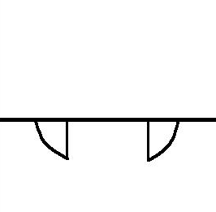

Here is the title right-side-up:

"__ __ __ __ __ __ - __ __ __ __ __ __ __ __ __ __ __ ."

5 2 6 3 13 4 7 5 2

Here is the title upside-down:

"__ __ __ __ __ __ __ __ __ , __ __ __ __ __ __ __ __ __ __ __ __ __ __ __ __ __ __ ."

8 12 6 11 7 9 6 10 8 10 6 3 9 10 1 8 7 14 6

To determine the titles to this comic, complete the problems and activities. Then replace each numbered blank with the letter corresponding to the answer for that problem. The unnumbered blanks are all vowels. You should be able to determine both titles.

- A 1000 kg rocket is launched upwards with an acceleration of +3.5 m/s². Determine the applied force on the rocket.

Use the information below to answer the next two questions.

A 750 kg car starts from rest and travels 100 m. It reaches a final velocity of 21 m/s. The car’s engine applies a force of 2650 N.

- What is the car’s acceleration?

- Determine the force of friction acting on the car.

- A sign with a mass of 23 kg is hung from cables as shown in the diagram. Determine the Tension in T₁.
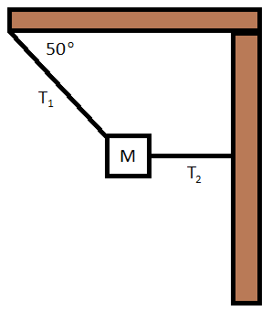
- A box is suspended from two cables. Each cable experiences a Tension of 450 N. Determine the mass of the box.
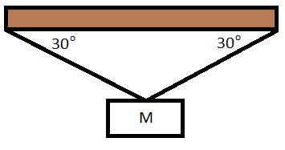
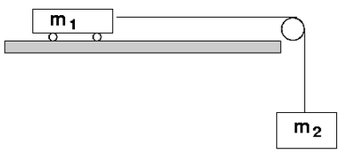
- To determine the mass of a toy car Mr. Doktor places the car on a table, connects a string to the car and pulls the string over a pulley. A 350 g mass is hung from the string. The acceleration of the car is measured to be 1.91 m/s. What is the mass of the car?

- A 350 kg elevator is pulled by a cable that experiences a Tension of 3100 N. Determine the acceleration of the elevator.
- While riding in an Elevator Mr. Haak takes out his trusty bathroom scale and notices his apparent weight is 30% higher than normal. Determine the acceleration of the elevator.

- The International Space Station orbits the Earth at an altitude of 400 km. Determine the acceleration due to gravity at this point.

- A 1000 kg Zamboni travels with a velocity of 3.5 m/s across an ice rink. The engine applies a force of 225 N. Determine the Force of Friction.

- Two stars experience a force of gravity of 1.15 x 10²⁷ N. Star A has a mass of 3.5 x 10²⁸ kg and Star B has a mass of 1.4 x 10³⁰ kg. How far apart are the stars?

- The mass of Jupiter is 1.89 x 10²⁷ kg. How far from the center of the planet would an astronaut have to be to experience a gravitational field of 9.81 N/kg?

- The weight of an astronaut is 800 N in a location where the acceleration due to gravity is 11.5 N/kg. Determine the astronauts mass.

- Three blocks are set up on a frictionless table as shown below. When the blocks are released they accelerate so the unknown mass rises with an acceleration of 1.5 m/s^{2.} Determine the unknown mass.
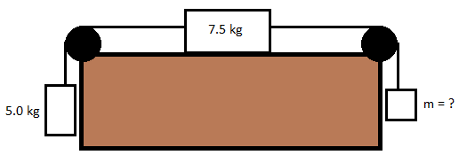

Answers:
R = -0.953 m/s²
M = 2.68 kg
H = 4.5 x 10¹⁰ m
C = 450 N
S = 1.45 kg
P = 992 N
N = 225 N
G = 13.3 kN
L = 2.21 m/s²
T = 2.94 m/s²
D = 295 N
K= 8.68 m/s²
W = 1.13 x 10⁸ m
F= 69.6 kg

