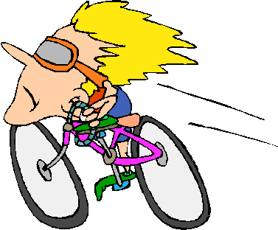

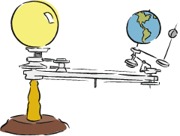

Dynamics
Student Examples Package
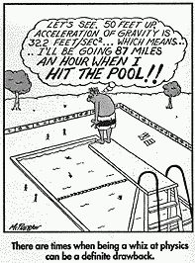
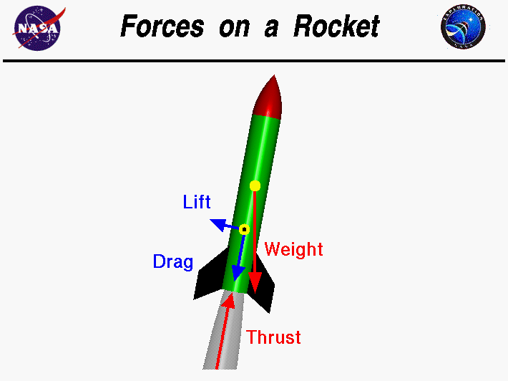

Lesson 1: Free Body Diagrams
- A rocket is sitting on its launch pad. Draw a F.B.D.

- The rocket fires its engines and flies upwards. Draw a F.B.D of the rocket in the air.

- Use the free body diagrams below to determine the resultant force.

- Draw a FBD for the situations below and identify the direction of the unbalanced force.
  - A skydiver jumps out of an airplane and falls towards the Earth.

  - After opening his parachute the skydiver floats to the ground.

  - A cannonball (projectile) is travelling through the air.

  - A textbook resting on a desk is pushed to the left by a student.

Lesson 2: Newton’s Laws of Motion
- Describe the forces acting in the following situations and explain if they are or are not examples of Newton’s first Law:
  - A book sits motionless on a table

  - An airplane flies through the air at a constant speed

  - An elevator starts from rest and begins to travel from the first to the fifth floor

- Use Newton’s first law to explain what why people are injured in car accidents when they do not wear seat belts.

- Use Newton’s first law to explain what why people are injured in car accidents when they do not wear seat belts.

- A 1000 kg car accelerates at +1.5 m/s². Determine the net force applied to the car.

- A car is accelerating at a rate of 3.0 m/s². If the net force is doubled and the mass is tripled what will the new acceleration be?

- A force of 350 N is applied to a 75 kg box.
  - Determine the box’s acceleration.

  - If the box was originally at rest what would its velocity be after 2.0 s?
- A physics student attempted to demonstrate Newton’s 2nd law. She pulled a cart with varying forces as shown below.
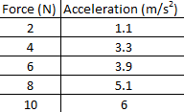
  - Graph this data. What is the manipulated and the responding variable?

  - Identify any outliers.

  - Use your graph to determine the mass of the cart.

- In a three-way tug of war three teams pull on a rope with the following forces:
F₁ = 30 N East
F₂ = 20 N North
F₃ = 50 N West
Determine the net force and the acceleration of the rope.

- The object below has a mass of 2.0 kg. Determine the net force acting on it then determine its acceleration.
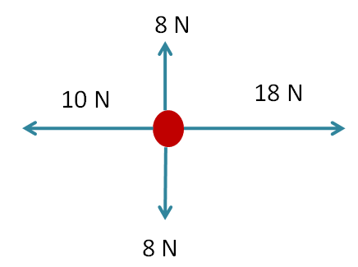

- Two people are pushing a broken car (m = 650 kg). The first person pushes with a force of 425 N and the second person pushes with a force of 250 N. Friction acts in the opposite direction with a force of 380 N. Determine the acceleration of the car.

Lesson 3 – Newton’s Third Law
- The space shuttle has a mass of 2.1 x 10⁶ kg. During lift off it applies a force of 2.8 x 10⁶ lbs of thrust ( 1 lbs ≈ 4.4 N). The earth has a mass of 5.98 x 10²⁴ kg. Draw a diagram showing the action reaction pair and calculate the acceleration of the shuttle and of the earth.

- A weightlifter stands up from a squatting position holding a dumbbell across his shoulders. Identify all the force pairs

- Find action reaction pairs in the following situations:
  - Firing a potato gun

  - Throwing a basketball

  - A parachute ‘splat’ landing

  - Hockey Body check

- While in space a 75 kg astronaut throws a 4.5 kg wrench. The wrench is accelerated over a distance of 1.0 m and reaches a final velocity of 20 m/s.
  - Determine the magnitude of the force applied to the wrench. What is applying this force?

  - What is the magnitude of the force acting on the astronaut?

  - What is the acceleration of the astronaut?

  - What will the astronaut’s final velocity be?

- When Mr. Doktor (m=60 kg) does a push up he is so Strong that he actually pushes the Earth down with a maximum force of 35 N.
  - What is the maximum force the Earth exerts on him?

  - What is Mr. Doktor’s maximum acceleration?

  - What is the Earth’s maximum acceleration? (m_{E} = 5.98 x 10²⁴ kg)

Lesson 4 – Normal Force & Weight
- Calculate your weight on Earth.

- The acceleration due to gravity on the moon is 1/6 what it is on Earth. Find the weight of a 350 kg piano on the moon.

- Mike the mighty explorer has a mass of 60 kg. If his weight on the sun is 1.6 x 10⁴ N determine the acceleration due to gravity on the sun.

- Determine the normal force experienced by a 45 kg person standing on a horizontal surface.

- Calculate the Normal force acting on a 13.5 kg object resting on an inclined plane at 30.0º.

- A 60 kg athlete skies down a 35⁰ slope. Determine her normal force.

- While on a incline Mike the mighty explorer experiences a normal force of 400 N. If Mike’s mass is 60 kg determine the angle the incline is raised at.

Lesson 5 – Applications of Newton’s Laws
- A tightrope walker experiences a force of gravity of 400 N while standing on a rope. What is the magnitude of the force supporting him?
- Mike the mighty explorer is driving his car along a flat road at a constant speed. The engine is applying a force of 1.2 x 10³ N.
  - Draw an F.B.D. representing this situation.

  - What is the force of static friction?

- Determine the unknown force if the mass below does not accelerate.
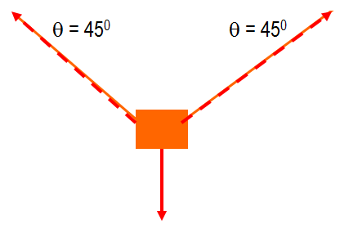

- Determine the unknown forces acting on the mass.

- Mike the mighty explorer is pushing a 35.0 kg crate. Mike applies a force of 100 N and a 75.0 N frictional force opposes Mike. Determine the acceleration of the crate.

- A 1000 kg elevator is being raised by a cable that exerts a 2.7 x 10⁴ N upwards force. At the same time it experiences a 2.5 x 10⁴ N force of gravity. What is the acceleration of the elevator?

- What would the acceleration of the elevator in the previous question be in the tension in the cable was 2.1 x 10⁴ N?

- A rocket with a mass of 2000 kg experiences a force of gravity of 5000 N while flying horizontally over the surface of a distant planet. At its present speed there is a 2500 N drag force. The engine is tilted to provide thrust angled downwards. The pilot turns up the thrust to 10500 N and continues flying horizontally. What is the acceleration?

- A 1200 kg elevator rises at 2.4 m/s². What is the force exerted by the elevator cable?

- What would the tension be on the cable if the elevator was accelerating downwards at 2.4 m/s²

- While riding at a constant speed in an elevator a man has a weight of 670 N. What would a scale read if the elevator was accelerating upwards at 1.0 m/s²? Downwards at 1.0 m/s²?

- Mike the mighty explorer has a mass of 85.0 kg. While riding on an elevator he pulls out his trusty bathroom scale. As the elevator stops it gives a reading of 730 N. Was it moving up or down? If it was moving at 6.5 m/s how long would it take to stop?

Lesson 6: Universal Gravity
- Determine the force of gravity between you and the person nearest to you.

- Mike the mighty explorer (m = 60kg) is attracted (gravitationally) to his pet aardvark (m = 15 kg). If they are 2.5 m apart, determine the force of (gravitational) attraction between them.

- The gravitational force between two objects of equal mass is 3.5 x 10⁻⁹ N when the objects are separated by 3.5 m. Determine each objects mass.

- a) If two objects each with mass m are separated by distance d what equation represents the force of gravity between them?

b) If one of the masses is increased to 2m how many times greater will the new force of gravity be?

c) If both masses are m but the separation is doubled how many times greater will the new gravitational force be?

d) If one mass is tripled and the separation is doubled how many times greater will the new gravitational force be?

- Using a Torsion balance a Physicist determined the Force of Gravity between two 5.0 kg medicine balls.
Gravitational Force (N) | Separation (m)
4.06 x 10⁻⁸ | 0.20
1.02 x 10⁻⁸ | 0.40
4.51 x 10⁻⁹ | 0.60
1.33 x 10⁻⁹ | 0.90
1.35 x 10⁻⁹ | 1.10
7.22 x 10⁻¹⁰ | 1.50

Graph the data:

What is the proportional relationship between F and r?

Using the data above create a linear graph of F and r.

Use the graph to determine the Universal Gravitational Constant ‘G’.

- Three medicine balls are placed in a row as shown below. Determine the Net Force acting on the middle ball. What is its acceleration?
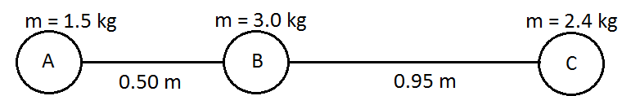

- Three metal balls are arranged in a triangle as shown in the diagram:
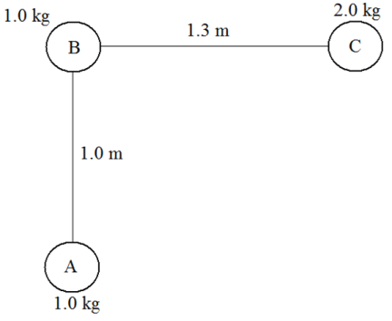

- Draw a FBD showing the gravitational forces acting on ball B.

- Determine the magnitude and direction of the acceleration of B due to gravitational forces.

Lesson 7: Gravitational Fields
- Mr. Doktor has a mass of 60 kg and experiences a Force of Gravity of 589 N on the Earth’s surface. Determine the gravitational field strength at this point.

- The International Space Station orbits 400 km above the surface. On the space station Mr. Doktor experiences a gravitational force of 521 N. Determine the gravitational field strength at this point.

- Calculate the gravitational field strength at the surface of the Earth (r = 6.38 x 10⁶ m and m =5.98 x 10²⁴ kg).

- The closest black hole to Earth is Cygnus X-1. It has a mass of 3.0 x 10³¹ kg (15 times larger than the sun!) and a radius of 44 km.
  - Determine the acceleration due to gravity on the surface of this black hole.

  - What would your weight be ‘on’ Cygnus X-1?
- There is a supermassive black hole at the Center of the Milky Way with a mass larger than 4.1 MILLION stars the size of the sun (m_{sun} = 1.98 x 1030 kg). How far from this black hole would you have to be to experience a gravitational field equal to 9.81 N/kg?

Lesson 6: Friction
- A 5.0 kg block is sliding across a horizontal table with a coefficient of friction of 0.25. What is the force of friction?

- A force of 14 N is needed to keep a 40 N block moving at a constant velocity. What is the coefficient of kinetic friction between the block and the surface?

- Peter and Michael are sliding a 300 kg safe across the floor to their getaway car. The safe slides with a constant speed if Peter pushes from behind with a force of 300 N and Michael pulls with a rope from in front with a force of 390 N. What is the coefficient of friction between the safe and the floor?

- A force of 500 N is used to push a 200 kg box along a surface that has a 378 N frictional force. What is the acceleration of the box?

- What force is required to give a 70 kg person an acceleration of 0.82 m/s² if the coefficient friction is 0.422?

- A force of 700 N was applied to a 500 kg piano giving it an acceleration of 0.25 m/s². What is the coefficient of kinetic friction?

Lesson 7: Forces in 2D
- Three forces act on an object as shown on the board. Determine the net force on the object.

- Three forces act on an object as shown on the board. Determine the net force on the object.

- A 15.0 kg object has three forces acting on it. Determine the magnitude and direction of the object`s acceleration.

- An object that does not experience any acceleration has 3 forces acting on it. The first two forces are shown below. Determine the magnitude and direction of the third force.

- A 20 kg box is being pulled across a horizontal surface that has μ = 0.25. Determine the acceleration of the box if:
  - The box was pulled horizontally with a force of 60 N.

  - The box was pulled by a rope as shown below:
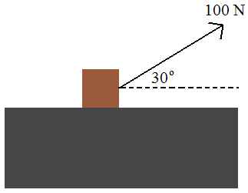

Lesson 8: Components of Force
- A force of 15 N is applied against a wall at an angle of 30⁰ to the horizontal. How much force is directed horizontally and vertically?

- A 15.0 kg wagon is accelerated by a force of 20 N along its handle. If the handle is pulled at an angle of 20⁰ to the horizontal what is the wagon’s acceleration?

- To push a 35.0 kg lawnmower Mike the mighty explorer applies a force of 120 N down the handle at an angle of 55.0º to the vertical. Along what line does the lawnmower accelerate? At what rate does it accelerate?

- A sign is held by the ropes as shown on the board. Find the tension in each of the ropes. Hint: What weight does each rope have to support?

- Two students hold a string with a mass in the middle.
  - Measure the angle of depression in the string and then determine the tension.

  - What does the tension need to be in order for the angle of depression to be 0⁰?

- A sign is supported by two wires as shown on the board. Determine the Tension in the wires.

Lesson 9: Inclined Planes
- A 1.5 kg book slides at a constant velocity down a 30⁰ incline plane. Determine the coefficient of friction between the incline and the book.

- A 50 kg box at the top of a 30º inclined plane slides down, accelerating at 2.5 m/s². What is the coefficient of friction between the ramp and the box?

- Mike the mighty explorer (m = 55 kg) is having fun at a park. He slides down a straight slide that is inclined at a 38⁰. During this time he is acted upon by his weight, normal force, and kinetic friction.
  - Draw a FBD

  - How large is the normal force

  - What does the coefficient of friction need to stop him from accelerating?

  - If the length of the ramp was 18 m what was the velocity of the box at the bottom of the ramp?
- A piano (250 kg) is being loaded onto a truck by a ramp angled at 20⁰. A worker pushes the piano up the ramp with a force of 1500 N. The coefficient of friction between the piano and ramp is 0.10. Determine the acceleration of the piano.

- A pulley is constructed on a ramp as shown below. If the coefficient of friction between the block and the ramp is 0.20 determine the acceleration of the pulley system.
