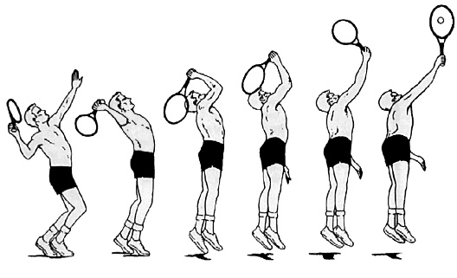

Physics 20
Kinematics Examples
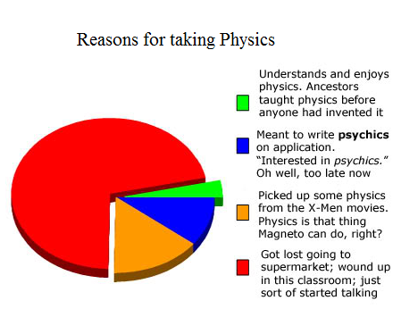

Lesson 1: Vectors, Scalars & PT Graphs
- The diagram below shows the path a student takes to get to school. Determine her distance and displacement.
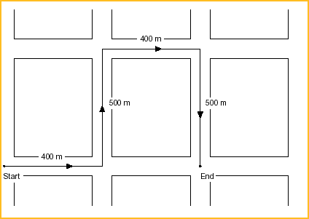
- During a road trip a car travels +100 km, +75 km and -280 km. Determine the final position of the car.

- The position-time graph below shows an airplane during takeoff.

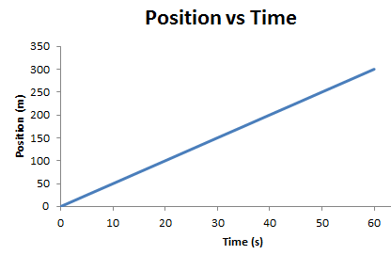

- Determine the position of the plane at t = 2.0 s.

- How long does it take the plane to travel 25 m?

- What is the average velocity of the plane?

- A car accelerates from rest to its top speed in 3.5 s. Use the graph below to determine the instantaneous speed at 2.0 s.

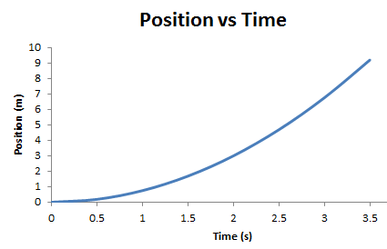

- The graph below shows two runners in a race.
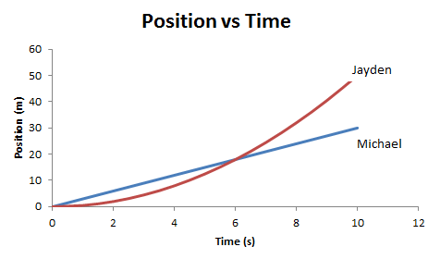

- Describe the difference between the two runners.

- Who finishes the race first?

- At what time does Jayden pass Michael?

- At 4.0 s determine each boy’s speed.

- The graph shows the position a car rolling down a steep hill.
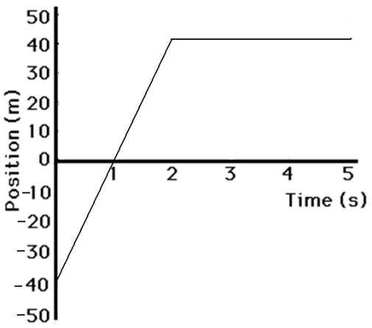
- How long does it take the car to travel 40 m?

- What is the car’s velocity between 0 s and 2 s?

- What is the car’s velocity between 2 s and 5 s?

- Determine the car’s average velocity from 0s to 5 s.

Lesson 2: Velocity & Speed
- A dog runs 10 m north and then turns around and runs 18 m south. If it takes the dog 32 s:
  - What is the average speed?

  - What is the average velocity?

- A photon travels with a speed of 3.0 x 10⁸ m/s. How long does it take to travel from the Earth to the sun (d = 1.49 x 10¹¹ m)?

- A bird flies north at 7.5 m/s for 2.0 minutes. Now, its tired so it slows down to 4.5 m/s. It now travels at this speed for 2.0 more minutes. Finally it turns around a flies the other direction at 6.0 m/s for 3.0 min. Find:
  - Create a Position-Time graph that shows this motion

  - Determine the average velocity of the entire trip

  - Determine the average speed of the entire trip.

- The sun orbits around the center of the Milky Way with an orbital speed of 220 km/s. The orbital radius it makes is approximately 1.56 x 10²¹ m. How many years does it take for the sun to make one complete trip around the Milky Way?

Lesson 3: Velocity-Time Graphs
- Sketch a velocity-time graph showing positive acceleration, negative acceleration, and zero acceleration.
- Sketch a velocity-time graph that shows an object with negative velocity and positive acceleration.
- The graph below shows the velocity of an alien space ship traveling to Earth. 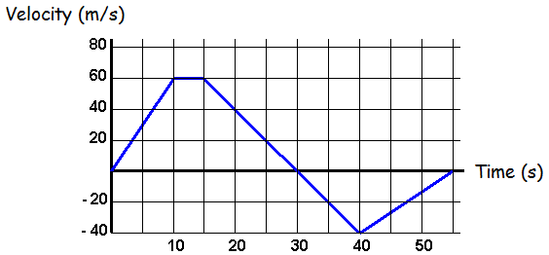

- During what time intervals does the spaceship have positive velocity? Negative velocity?

- At what time(s) is the spaceship stationary?
- Determine the acceleration of the spaceship along each interval.

- How far does the space ship travel between 0s and 10s? 10s and 15s? 15s and 30s? 30s and 40 s? 40s and 55s?

- What is the total displacement of the spaceship? What is the total distance travelled?

- Using your above information, sketch a position time graph for the spaceship.

- The graph below shows the velocity of a mail truck. Use the velocity time graph below to answer the following questions.
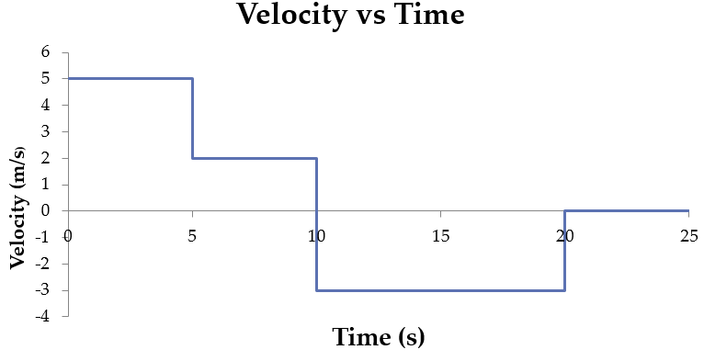
- What is the truck’s maximum velocity?

- Determine the total displacement of the truck.

- What is the average acceleration of the truck at 15 s?

Lesson 4: Acceleration
- In a particle accelerator a proton starts from rest and reaches a velocity of +2.5 x 10⁶ m/s in 1.3 x 10⁻⁶ s. Determine the acceleration of the proton.

- The Tesla model S has an acceleration of 11.1 m/s². How long will it take to reach 100 km/h if it starts from rest?

- A ball is rolled up a hill with an initial velocity of +5.0 m/s. The ball experiences an acceleration of -0.75 m/s² for 8.0 s. What will its final velocity be?

- During takeoff an airplane accelerates at a rate of +2.5 m/s². If the plane starts from rest, how long does it take to reach its takeoff speed of 175 m/s?

- In groups decide which of the following are possible and give an example.
  - Positive acceleration and positive velocity
  - Positive acceleration and negative velocity
  - Negative acceleration and positive velocity
  - Negative acceleration and negative velocity
  - Zero acceleration and negative velocity
  - Positive acceleration and zero velocity.

Lesson 5: Displacement Equations
- An airplane starts from rest and accelerates to 125 m/s over 10 s. How far does the airplane travel?

- Mike the mighty explorer travels 100 m in 15 s. If his final velocity was 7.5 m/s determine his initial velocity.

- A car travels -35.0 m in 20 s. If its initial velocity was 5.0 m/s determine its final velocity.

- Mike the mighty explorer starts from rest and accelerates at +1.5 m/s² for 3.0 s. How far has he travelled?

- A car is travelling at 30 m/s when the driver sees a deer in the road 100 m in front of him. If it takes the driver 4.5 s to come to a stop right in from of the deer at what rate did he decelerate?

- A sprinter starts from rest and accelerates at a rate of 1.0 m/s². During this time he covers 100 m. How long was he running for?

- An airplane is traveling at 100 m/s when the pilot decides to speed up. The place accelerates at 1.0 m/s² while covering a distance of 200 m. How long does this take?

- An airplane starts from rest and accelerates at 1.5 m/s². During this time the plane travels 250 m. What is its final velocity?

- Mike the mighty race car driver is driving his car at +10 m/s. He pushes on the gas and accelerates at +2.0 m/s² and ends up with a final velocity of +17 m/s. How far did he travel?

Lesson 6: Acceleration-Time Graph
- The graph below shows the motion of a car. Use the graph to sketch an a-t graph.
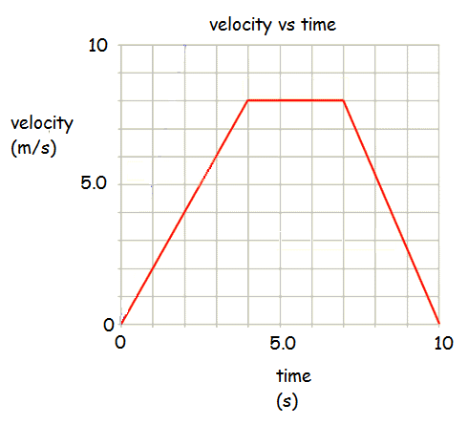

- Using the graphs, determine during which time intervals:
  - The car is accelerating
  - The car is decelerating
  - The car is not accelerating
  - The car is not moving
  - The car reaches its maximum velocity
  - The car reaches its maximum acceleration
  - The car has positive acceleration
  - The car has negative acceleration

- The graph below shows the acceleration of a car.
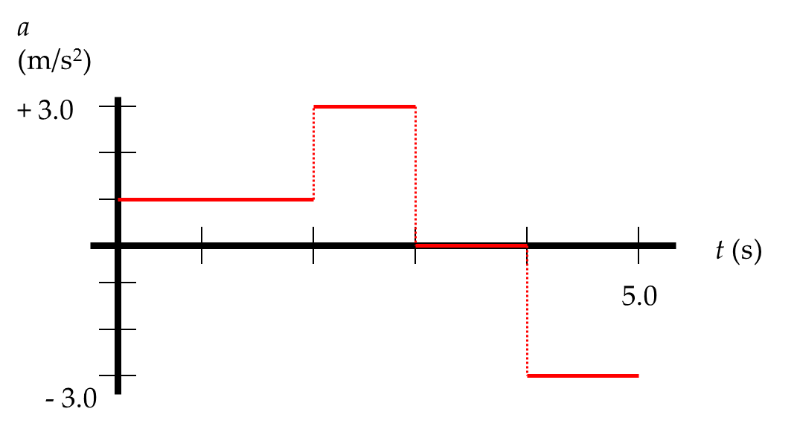
- If the car starts from rest, find its velocity at t = 5.0 s.

- Sketch a velocity-time graph showing this motion
- Use this graph to determine the car’s total displacement.

- Use the data below to sketch a position vs time graph.
Time (s) | Position (m) | Time(s) | Position (m)
0.0 | 0.0 | 8.0 | 4.0
1.0 | 1.0 | 9.0 | 6.0
2.0 | 2.0 | 10.0 | 8.0
3.0 | 3.0 | 11.0 | 10.0
4.0 | 4.0 | 12.0 | 12.0
5.0 | 4.0 | 13.0 | 14.0
6.0 | 4.0 | 14.0 | 16.0
7.0 | 4.0 | 15.0 | 18.0

What does your v-t graph tell you about the a-t graph?

Lesson 7: Freefall
- Felix Baumgartner set the world record for skydiving when he jumped from a balloon 39 km above the Earth. In the absence of air resistance determine:
  - The maximum speed he could have when he reached the Earth.

  - The time it would take him to fall to the Earth.

  - Due to air resistance Felix reached a maximum speed of 1358 km/h (Mach 1.1). It took him approximately 4 minutes to reach this speed. Determine the average acceleration during this time.

- An iPod is dropped from the top of the tower (30.0 m). Determine its velocity when it smashes into the ground.

- A second iPod is thrown downwards at -14.5 m/s.
  - What will it’s velocity be when it smashes into the ground?

  - How long will it take to hit the ground?

- A baseball is thrown upwards at +20 m/s.
  - What will its velocity be after 2.0 s?

  - What is the baseball’s displacement after 2.0 s?

- A ball was dropped from an airplane flying at 950 m. Ignoring air resistance, how long would it take for the ball to hit the ground?

Lesson 8: Vectors in 2D
- A girl runs at a 30.0⁰ N of W with a velocity of 2.5 m/s. What are the x and y components of her velocity?

- A car travels with a velocity of 55 km/h at 25⁰ N of E. What are the north and east components of this velocity?

- Add the two vectors shown below:
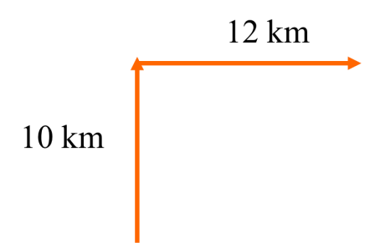

- Add the vectors below to determine the resultant:
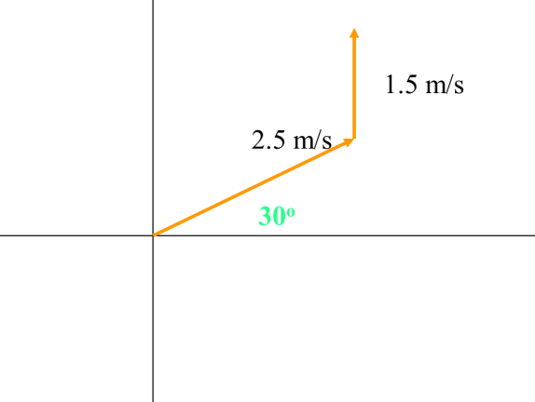

- Add the two vectors:
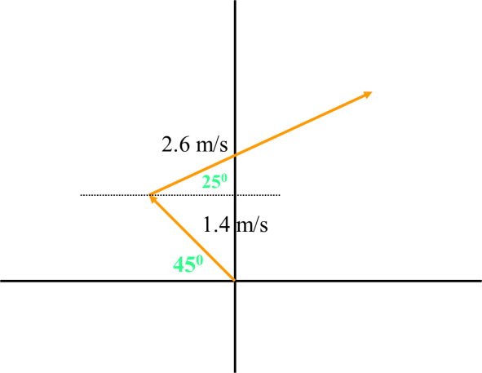

Lesson 9: Motion in 2D
- To fly from Vancouver to Edmonton a plane travels at 49⁰ N of E at 450 km/h.
  - How far east would the plane travel in 2 hours?

  - How far north would the plane travel in 2 hours?

  - If the wind pushes the plane’s velocity vector South how would that affect your previous answers?

- As a boat crosses a river that is 100 m wide its motor pushes it at 5.0 m/s East. The current pushes it at 3.5 m/s north.
  - What is the resultant velocity?

  - If the river is 125 m wide how long will it take the boat to cross the river?

  - How far downstream will the boat end up?

- A boat that can travel 6.0 m/s in still water heads directly north across a river with a current that flows at 3.0 m/s [E].
  - If the driver of the boat wants to end up directly south of where she starts what direction does she have to point her boat?

  - With what speed will the boat move relative to the shore?

Lesson 10: Horizontal (Type 1) Projectile Motion
- A baseball is thrown vertically upwards with an initial velocity of 15 m/s.
  - What will its velocity be at it’s highest point?

  - What is the ball’s maximum height?

  - How fast will the ball be moving after 1 s?

  - What will the ball’s velocity be when it strikes the ground?

- A cannon is fired horizontally from a 10 m cliff.
  - If the muzzle velocity is 55 m/s how long is the projectile in the air?

  - What is the range (horizontal displacement)?

- A ball is thrown horizontally from the top of a building at a velocity of 6.5 m/s.
  - If the object takes 7.5 s to reach the ground, how high is the building?

  - How far from the base of the building does the ball land?

- An object is thrown horizontally from the top of a building 85.0 m high. If the object hits the ground 67.8 m from the base of the building what was the horizontal velocity of the object?

Lesson 10: Projectiles Launched at Angles (Type 2)
- A football is thrown at a 15⁰ angle with a speed of 18 m/s.
  - What are the x- and y- components of its velocity the instant it’s fired?

  - What is its maximum height?

- An arrow is fired at a 30⁰ angle with an initial speed of 25 m/s.
  - What are the x- and y- components of its velocity the instant its fired?

  - How long is it in the air for?

  - How far does it travel?

- An archer on the top of a 15 m cliff fires an arrow at a 10⁰ angle to the horizontal. If the initial speed is 19 m/s what is the range?

- A cannon fires a shell at an angle of 30⁰ to the horizontal with an initial velocity of 125 m/s. If it strikes a mountain 350 m away, at what height above the ground did the shell strike?

- The longest ever sniper kill was recorded by a Canadian Special Forces Sniper in Iraq. He hit an ISIS militant 3.54 km away. The bullet was in the air for approximately 10 s. If the target was at the same height as the bullet was fired:
  - Determine the x-component of the velocity.

  - Determine the initial y-component of the velocity.

  - Determine the angle the gun had to be pointing.

- An archer stands on the top of a 15 m hill. If he fires an arrow at 45⁰ with a speed of 55 m/s determine:
  - The maximum height of the arrow.

  - The time the arrow is in the air.

  - The range.

  - The speed the arrow hits the ground.

