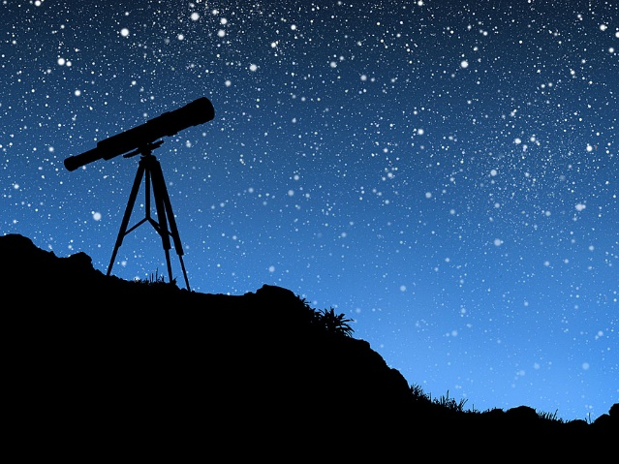
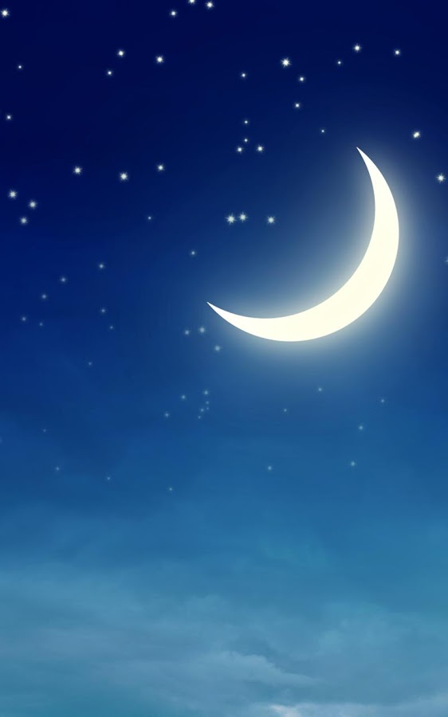

Astronomy 15
Unit 2
The Night Sky

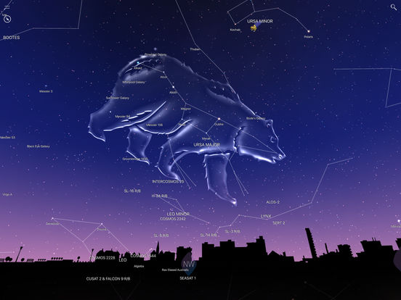

Lesson 1: Planet, Asteroid & Comet Motion
- What is the Geocentric Model of Planetary motion? What evidence is there for it?

- What are epicycles? Why were they necessary in a geocentric model?

- What is the Heliocentric Model of Planetary motion?

- Who was the first person in the Western World to develop a Heliocentric model? What were the main points of his model? What was correct? What was incorrect?

- What observations did Galileo make that supported the Heliocentric model?

- Is the Heliocentric model completely correct? Explain your answer.

Choose one of the following Planets or Asteroids and answer the questions below in two or three complete paragraphs. Include pictures or diagrams when appropriate.
Jupiter, Saturn, Mars, Venus, Mercury, Ceres, 4 Vesta, 2 Pallas, 99942 Apophis, 1036 Ganymed, Comet Halley’s Comet, Comet McNaught
- Sketch a diagram of the Orbit.
- When was the object discovered?
- Does the orbit cross the Earth’s orbit?
- How large is the object? What is it made of?
- How fast does it move?
- Does this object experience retrograde motion as seen from Earth?
- What other interesting facts can you find?

Lesson 2: Polaris, The North Star
Objective: Using Stellarium, identify where the North Star is.
Steps:
  - Open Stellarium and set the location to Edmonton.
  - Under the configuration window, find the information tab and select ‘customized’. Make sure only the following boxes are checked:
- Name
- Right Ascension (date)
- Altitude/Azimuth
- Distance
  - Using the PG DN key, zoon out until you can see most of the sky.
  - Adjust the direction until you are facing North. And adjust the time so the night sky is visible.
  - Press CTRL and + to advance the time by one hour. Do this several times until you can identify where the North Celestial Pole is.
  - Click on the star nearest to the North Celestial Pole.
  - Copy the information of the star (Name, RA/DEC, ALT/AZ/ Distance)
  - Press F5 to bring up the time/date window.
  - Set the year to -2800 and adjust the time so the night sky is visible.
  - Repeat steps 3 – 7 until you have identified a bright star closest to the North Celestial Pole.
  - Set the year to 27200 and repeat steps 3 – 7.
  - Press F6 and choose a location in the Southern Hemisphere. Repeat these steps to determine the location of the South Celestial Pole.

Answer the following question:
- The name of the bright star closest to the North Celestial Pole is _________________________. This star is at an elevation of _________________________. Although this is currently the North Star, it has not always been. In the year 2800 BCE the North Star was _______________ and in the year 27200 the North Star will be ____________________. The change in the location of the North Celestial Pole is due to the wobble of the Earth’s rotational axis and is called _________________________.

- Aside from the position of the North Celestial Pole, what other changes occur 95000 years in the future?

- What constellation does the North Star belong to? What is the brightest star in this constellation?

Lesson 3: The Moon
- Explain what causes the phases of the moon.

- Using the internet find information about the next Lunar Eclipse. Will the total phase of the eclipse be visible from Edmonton? If not, will the penumbral phase be visible? Draw a picture showing the Sun, Earth and Moon when totality is at a maximum and indicate your location of the drawing of the Earth.

- Explain the difference between a Lunar and a Solar Eclipse.

- If the Moon’s orbital radius was suddenly doubled what effects would that have on observations made from Earth?

- What is the difference between the Umbra and Preumbra shadows?

- Would a person living on a lunar colony see the Earth going through Phases? Why or why not?

Lesson 4: The Galilean Moons
- What observations did Galileo make that reinforced the heliocentric model? Explain how these observations contradicted the geocentric model. Why could these observations not have been made before Galileo’s time?

- If you observed Jupiter for a single night would you see the moons moving?

- All the Galilean Satellites orbit Jupiter in the same direction. What conclusions can you draw from this about the formations of Jupiter and its satellites?

- Io is similar in size to the moon but lacks the impact craters the moon has. What explanation is there for this?

- Why do you think Ice makes up a significant percentage of Ganymede and Calisto but not the Earth or the moon?

- If you could replace our moon with Io, and Io could retain its volcanic activity what changes would this cause in the night time sky?

- If you were an evil genius looking for a moon base, which of the Galilean Satellites would choose and why?
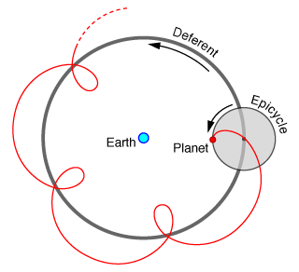
Stellarium & Retrograde Motion
Instructions
- Open Stellarium and press F6 to open the location window. Set the location to Edmonton
- Press A to turn off the atmosphere (this will make it easier to see the stars/planets.
- Press Z to turn on the Zenith grid.
- Set the time/date to April 6, 2016 at 23:00:00.
- Adjust the screen until you are facing due South with a field of view of about 110º. It should appear as below.
- Put a dot on the image above where you see Mars on this date by finding Mars position relative to the Right Ascension and Declination Lines.
- Press the = five times to move forward 5 days. Place another dot on the image.
- Repeat step 7 until the January 19th, 2017.
- Trace a line through the points. Write the beginning and end dates on above those points.

Questions
- Explain the motion of Mars relative to the background stars during this time interval.

- What causes Mars to appear to move this way?

- What other objects experience this type of motion?

- How did the ancient Greeks attempt to explain this motion?

- Draw a diagram of the orbits of Earth and Mars and use that to explain how this motion occurs.

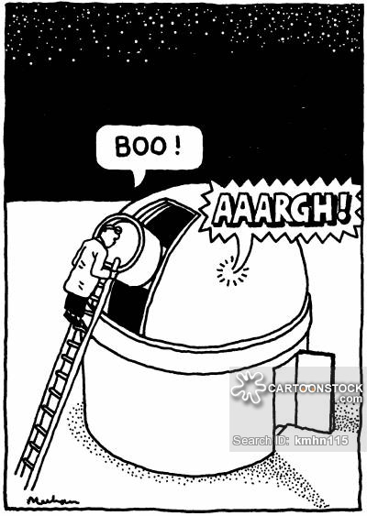

Galilean Moon Motion
Instructions

- Open Stellarium and press F6 to open the location window. Set the location to Edmonton
- Press A to turn off the atmosphere (this will make it easier to see the stars/planets.
- Press G to turn the ground off.
- Set the time/date to April 17, 2017 at 23:00:00.
- Jupiter will be in the South Eastern Sky. Click on the Planet and press the space bar.
- Press CTRL-M (this will change the orientation of the sky
- Press PgUp to zoom in on Jupiter. Zoom until the field of view is approximately 0.30º
You should see an image similar to the one below:

- Press L three or four times to increase the time speed. You should begin to see the moons moving around Jupiter. The period of a moon is how long it takes to complete one orbit. Watch each of the moons and determine their periods.
Moon | Period
Io
Europa
Callisto
Ganymede

- Press PgUp to zoom in on Jupiter again until the field of view is approximately 0.050º. You should be able to see surface features like cloud bands on the planet. Pick one of those features (like the big red spot) and watch it rotate. Adjust the speed again and determine how long it takes Jupiter to rotate.
Rotational Period of Jupiter: ___________________________
- Occasionally you may have noticed black circles moving across the face of Jupiter. What do you think they are?

Lesson 5: Brightness and Proper Motion
Instructions: Use the data about Scholz Star to answer the questions below.
Scholz Star
Distance Approximately 20 light years away
Apparent Brightness 18.3
Absolute Brightness 19.4
Mass 15% the mass of the Sun

- How bright will Scholz star be when it is 36 light years away?

- Scholz star was only discovered in 2013. Given that it is one of the 100 closest stars to Earth why did it take so long to discover?

- Explain why Scholz Star was not captured by the sun.

- In another 70,000 years will the star be closer or farther from the Sun? How will this affect its apparent brightness and its absolute brightness?

Lesson 6: Constellations and Star Positions
      - Complete the chart below:
Constellation | Part of Sky | Brightest Star | Right Ascension | Declination | What does the Constellation look like to you? | Notable Nebulae, Galaxies or Clusters in the Constellation

      - Research one of the constellations and explain the meaning and importance of that constellation to one ancient civilization.

