Diffraction Lab
Instructions:
- For each station write a procedure that describes (in step by step format) how you gathered the data at each step.
- Record all your observations (using data tables where necessary).
- Analyze your data using proper scientific techniques (proper graphical and averaging techniques where appropriate)
- Summarize your results with a conclusion that addresses the problem given at each station.

Station 1: Refraction and Diffraction
Use the diffraction grating on the aquarium, the laser and the ruler to determine the index of refraction of water.

Station 2: White Light Refraction
Use the ray box and the diffraction grating the determine the wavelength of red and blue light.

Station 3: CD Interference
Use the Laser and CD setup to determine the pit spacing on the CD.
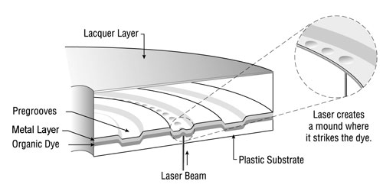
Station 4: Spectroscopic Analysis
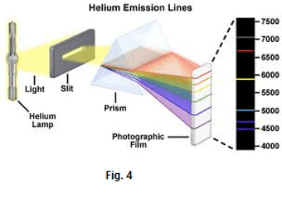
Use the spectroscope to determine the wavelength of one of the Emission Lines.

Diffraction Conceptual Problems
- The diffraction pattern below is formed when a blue laser is shown on a diffraction grating.
Explain how, if at all, the diffraction pattern would change if a student made the following adjustments:
- A red laser was used instead.
- The diffraction pattern was placed further from the laser.
- The screen was placed further from the diffraction grating.
- The diffraction grating was ruled with more lines per millimeter.
- The diffraction grating was placed in methanol (index of refraction of methanol 1.32)

- Explain the difference between reflection and transmission diffraction grating.

- Referring to path length difference, explain how bright and dark fringes are produced by a diffraction grating.

- When shining light on a CD explain why white light will produce a rainbow of colours but a laser will not.

- Draw a diagram of the spectra produced by a prism and a diffraction grating. Point out the similarities and differences between the two.

