Ion Drives
The Variable Specific Impulse Magnetoplasma Rocket (VASIMR) is the most efficient rocket propulsion system in operation today. Argon atoms are used as a propellant and in an ionization chamber they are given a charge of +e. They then pass through an accelerating potential and travel out of the back of the rocket at high speeds. In a VASIMR rocket the accelerating potential is created with plates that are 0.550 m apart with a potential difference of 2.0 x 10⁵ V.
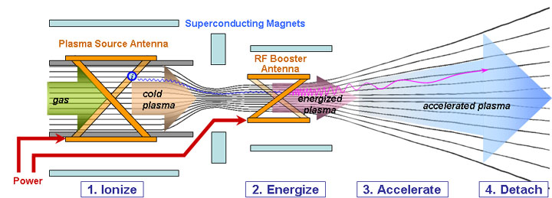
  - Determine the Electric Field inside the VASIMR.
  - How much kinetic energy does a single Argon atom gain travelling through the VASIMR?
  - The mass of one Argon atom is 6.63 x 10⁻²⁶ kg. Determine the velocity of an Argon atom after leaving VASIMR.
  - If VASIMR is being used to propel a 1000 kg space probe determine how many Argon atoms must be injected into VASIMR to give a change in velocity of 2500 m/s. (Hint: You will need to make use of conservation of momentum). How many moles of Argon would be required?
- The European Space Agency used an Ion Drive called the Hall Effect Thruster to send a space probe (SMART-1) to the moon. This Ion Drive generates an electric field of 1.73 x 10⁴ V/m and requires a potential difference of 5.0 kV.
  - How far apart should the plates in the capacitor be placed?
  - SMART-1 uses a singly ionized Xenon atom. Determine the change in Kinetic Energy of a Xenon atom as it is accelerated by SMART-1. If the mass of one Xenon atom is 2.18 x 10⁻²² kg determine the velocity of the Xenon atom.
- An experimental Ion Drive is using alpha particles as a propellant. The alpha particles are accelerated from rest to a velocity of 2.45 x 10⁴ m/s as the travel 25.0 cm through a parallel plate capacitor. Determine the Potential Difference and Electric field required by the Ion Drive.
- The first experimental Ion Drive was called NSTAR and accelerated charged particles through a potential difference of 2.3 kV. These charged particles gained 7.36 x 10⁻¹⁶ J of Kinetic Energy. What potential difference would be required to increase the Kinetic Energy to 1.00 x 10⁻¹⁵ J?
Motion Perpendicular to Electric Fields
A pair of parallel plates are connected to a 300 V power supply. The plates are separated by 0.10 m and are 0.50 m long. An electron enters a parallel plates next to the negative plate as shown in the diagram.
- On the diagram draw the direction of the electric field
- On the diagram, sketch the trajectory of the electron.
- Determine the magnitude of the electric field between the plates.
- Determine the magnitude of the electric force on the electron.
- Determine the magnitude and direction of the acceleration of the electron.
- If the electron strikes the left edge of the bottom plate, how long is the electron between the plates for?
- Determine the horizontal distance the electron travels.

Millikan’s Experiment
When trying to determine the charge on an electron a physicist focused on a single drop with a mass of 9.10 x 10⁻¹⁷ kg as shown below:
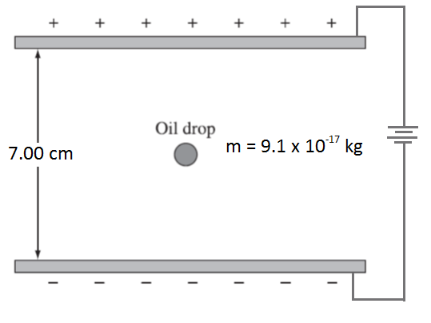
When placed in between two parallel plates with a variable potential difference and separated by 7.0 cm she gathered the following data:
Potential Difference (V) | Acceleration of oil drop (m/s²)
50.0 | -2.10
75.0 | +1.59
100 | +5.38
125 | +8.95
150 | +13.04

- Use this data to determine the acceleration due to gravity.
- Use this data to determine the charge on an electron.
- What voltage will cause the oil drop to be suspended?

